Ex2: Configure CI pipeline for automated build using GitHub Actions

Aim
To configure a GitHub Actions CI pipeline that automatically builds a Maven-based Java application whenever code is pushed to GitHub.

Software Required
- Windows 10/11
- JDK 17 or later
- Maven
- Git
- GitHub account
- GitHub repository
- VS Code / IntelliJ IDEA / Eclipse

step by step procedure
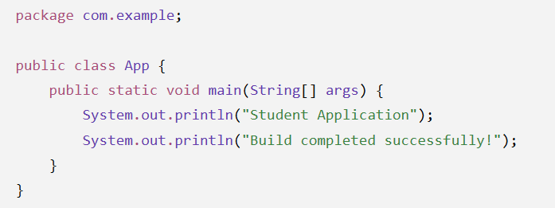Create a simple Maven Java application.
Project structure:
StudentApp
│
├── pom.xml
└── src
└── main
└── java
└── com
└── example
└── App.java

Step1:Create Maven Project
Open Git Bash / Command Prompt.
Create the project: mkdir StudentApp
cd StudentApp
Create the required Maven folders: mkdir -p src/main/java/com/example
Create App.java inside: src/main/java/com/example/App.java

Step2: Create pom.xml
Create inside the project folder
pom.xml

<project xmlns="http://maven.apache.org/POM/4.0.0"
xmlns:xsi="http://www.w3.org/2001/XMLSchema-instance"
xsi:schemaLocation="http://maven.apache.org/POM/4.0.0
https://maven.apache.org/xsd/maven-4.0.0.xsd">

<modelVersion>4.0.0</modelVersion>

<groupId>com.example</groupId>
<artifactId>StudentApp</artifactId>
<version>1.0</version>

<properties>
<maven.compiler.source>17</maven.compiler.source>
<maven.compiler.target>17</maven.compiler.target>
</properties>

</project>

Step3.Perform Manual Build First
Before automating anything, students should understand what is being automated.
Run:
mvn clean package

After successful execution, check:
target/
└── StudentApp-1.0.jar

Step 4:Create Git Repository
Inside the project:
git init
Check:
git status
Add files:
git add .
Commit:
git commit -m "Initial StudentApp project"

Step 5: Create GitHub Repository
Go to GitHub and create a new repository.
Repository name:
StudentApp

Step 6: Connect Local Project to GitHub
Copy the repository URL.
Example:
git remote add origin https://github.com/USERNAME/StudentApp.git
Check: git remote -v
Push: git branch -M main
git push -u origin main

Step 7: Create GitHub Actions Workflow
Inside the project, create:
.github
└── workflows
└── build.yml
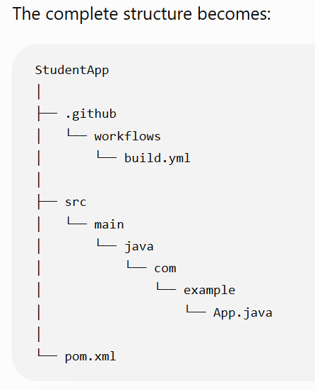

Step 8: Write build.yml
name: Java Maven Build

on:
push:
branches:
- main

jobs:
build:

runs-on: ubuntu-latest

steps:

- name: Checkout source code
uses: actions/checkout@v4

- name: Set up JDK
uses: actions/setup-java@v4
with:
java-version: '17'
distribution: 'temurin'

- name: Build with Maven
run: mvn clean package

Step 9: Commit the Workflow
Run:
git add .
Then:
git commit -m "Add GitHub Actions CI build"
Push:
git push

step 10. Test the Automation
Modify App.java.
For example:
System.out.println("CI Pipeline is working!");
Save the file.
Then:
git add .
git commit -m "Update application"
git push
GitHub automatically starts another build.
Students should observe:
Code Change
↓
git push
↓
GitHub Actions triggered
↓
Maven Build
↓
Success
Result: The GitHub Actions CI pipeline was successfully configured. Whenever the source code was pushed to the GitHub repository, the workflow was automatically triggered and the Maven project was successfully built. The build status was verified as successful in the GitHub Actions tab.

